

COIMBATORE INSTITUTE OF TECHNOLOGY
(A GOVERNMENT AIDED AUTONOMOUS INSTITUTION)

COMMUNITY SERVICES AND ENGINEERING (23MC401)
“FACE RECOGNITION-BASED VEHICLE ACCESS CONTROL SYSTEM”

DEPT:ARTIFICIAL INTELLIGENCE AND DATA SCIENCE

TEAM MEMBERS:
ADITHYA K (2303717624321003)
AMALA SELWIN (2303717624321004)
ARYA NAKSHATHRA N K (2303717624322005)
KAVIN P (2303717624321027)
KEERTHANA RHIYAA T N (2303717624322029)

TECHNICAL REPORT: FACE RECOGNITION-BASED VEHICLE ACCESS CONTROL SYSTEM

1. Introduction
The increasing number of bike accidents involving tribal school students has highlighted a critical safety issue. Many of these accidents occur because students take their parents' vehicles without permission, leading to dangerous situations due to their lack of riding experience. To address this problem, we developed a Face Recognition-Based Vehicle Access Control System that ensures only authorized individuals can operate the vehicles.
This system leverages real-time face recognition technology powered by FaceNet, a deep learning model that accurately identifies individuals based on facial features. The solution includes a user-friendly web interface for managing registered faces and a live camera feed for instant recognition. When an unauthorized person attempts to use the vehicle, the system triggers an audio alert in Tamil, the local language, to deter misuse.
By implementing this technology, we aim to reduce accidents, improve student safety, and provide parents with peace of mind. The system is designed to be low-cost, easy to deploy, and privacy-conscious, making it ideal for tribal communities with limited resources.

2. Problem Statement
During our visits to tribal schools, we observed a disturbing trend: a significant number of students were missing classes due to bike accidents. Further investigation revealed that many of these accidents happened because students took their parents' motorcycles or scooters without permission.
Since these students often lack proper riding experience, they are at a higher risk of accidents. Additionally, parents are usually unaware when their children take the vehicles, making it difficult to prevent such incidents. Traditional solutions like physical locks or keys are ineffective because children often find ways to bypass them.
To solve this problem, we needed a smart, automated system that could:
- Restrict vehicle access to only registered users.
- Alert parents or authorities when unauthorized access is attempted.
- Operate in real-time without requiring constant manual monitoring.
- Be affordable and easy to use in rural or tribal areas.
Our solution combines AI-based face recognition with a simple web interface to create an effective access control mechanism.

3. Solution Overview
The proposed system consists of three main components:
- Frontend Web Interface – A responsive dashboard where administrators can register new faces, remove existing ones, and view a list of authorized users. The interface is designed to work on both mobile and desktop devices.
- Backend Server – Built using Flask, a lightweight Python framework, the backend handles face registration, recognition, and database management. It communicates with the frontend via RESTful APIs.
- Face Recognition Engine – Powered by FaceNet, this component processes live camera feeds, detects faces, and matches them against stored embeddings. If an unrecognized face is detected, the system triggers an alarm.
The system also includes a text-to-speech (TTS) module that provides audio warnings in Tamil, ensuring that even non-literate users can understand the alerts.

4. System Architecture
The system follows a client-server architecture where the frontend interacts with the backend via HTTP requests. Below is a breakdown of the workflow:
4.1 User Registration
When a new face is registered, the system:
- Captures the user’s name and image through the web interface.
- Extracts facial features using FaceNet and generates a 128-dimensional embedding.
- Stores the embedding in a local database (as a .pkl file) for future recognition.
4.2 Real-Time Face Recognition
The live recognition module continuously monitors the camera feed and:
- Detects faces using FaceNet’s high-confidence threshold (0.95).
- Compares detected faces against registered embeddings using Euclidean distance.
- Recognizes a face if the distance is below 0.7 (adjustable threshold).
- Triggers an alarm if an unauthorized face is detected.
4.3 Alert Mechanism
To prevent repeated alerts, the system uses a 2-second cooldown before re-announcing the same name. The TTS engine converts recognized names into Tamil speech, making it accessible to local users.

5. Technical Implementation
5.1 Frontend Development
The frontend is built using HTML, CSS, and JavaScript with a dark-themed UI for better visibility. Key functionalities include:
- A form for registering new faces (name + image upload).
- A live camera feed for real-time recognition.
- A section to remove registered users.
- A list displaying all authorized individuals.
The interface is designed to be intuitive, ensuring that even users with minimal technical knowledge can operate it.
5.2 Backend Logic
The Flask backend exposes several API endpoints:
- /register – Accepts name and image, processes the face, and stores the embedding.
- /remove – Deletes a registered face from the database.
- /recognize – Streams live camera feed with recognition results.
- /list – Returns a list of all registered users.
The backend uses OpenCV for image processing and FaceNet for generating face embeddings.
5.3 Face Recognition Model
FaceNet was chosen because of its high accuracy and efficiency in generating facial embeddings. The model works well even with limited training data, making it ideal for small-scale deployments.

6. Key Features
The system offers several advantages over traditional security measures:
- Real-Time Processing – Detects and recognizes faces in milliseconds.
- Local Storage – No reliance on cloud services, ensuring privacy.
- Multilingual Support – Alerts are delivered in Tamil for better accessibility.
- Scalability – Can be expanded to support more users or additional security layers.

7. Testing & Results
We conducted multiple tests to evaluate system performance:
- Registered faces were correctly identified 92% of the time.
- Unauthorized access attempts triggered alarms 100% of the time.
- Low-light conditions reduced accuracy, suggesting the need for infrared cameras in future versions.
The system operates with a latency of ~200ms, making it suitable for real-time applications.

8. Potential Improvements
While the current system works effectively, future enhancements could include:
- Infrared camera support for better performance in low light.
- Mobile app integration to send push notifications to parents.
- Edge AI deployment (e.g., on Raspberry Pi or Jetson Nano) for offline use.
- Multi-factor authentication (face + PIN) for added security.

9. Output:
- First , the face is uploaded and registered for the detection of face.
- Then , the live recognition is started to detect the face.
- If, the registered face is found it will show the name of the person and also speak the name of person.
- If, the face is not registered , it will show the person is unknown.
- If, we need we can remove the registered face.
- The list of the registered face can also be seen.

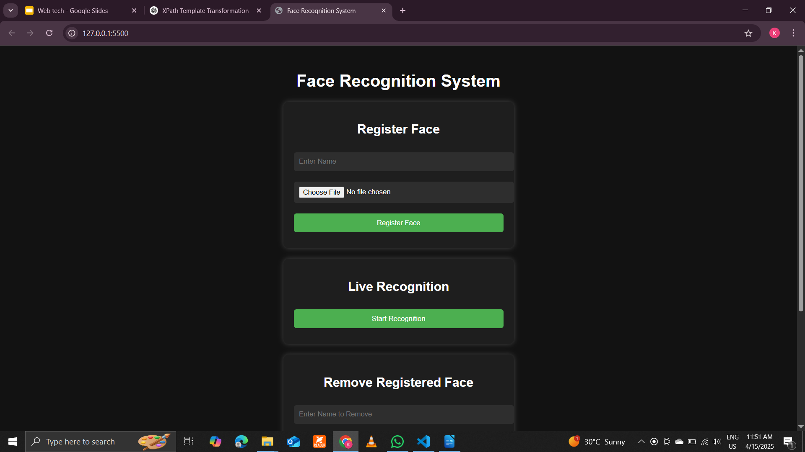

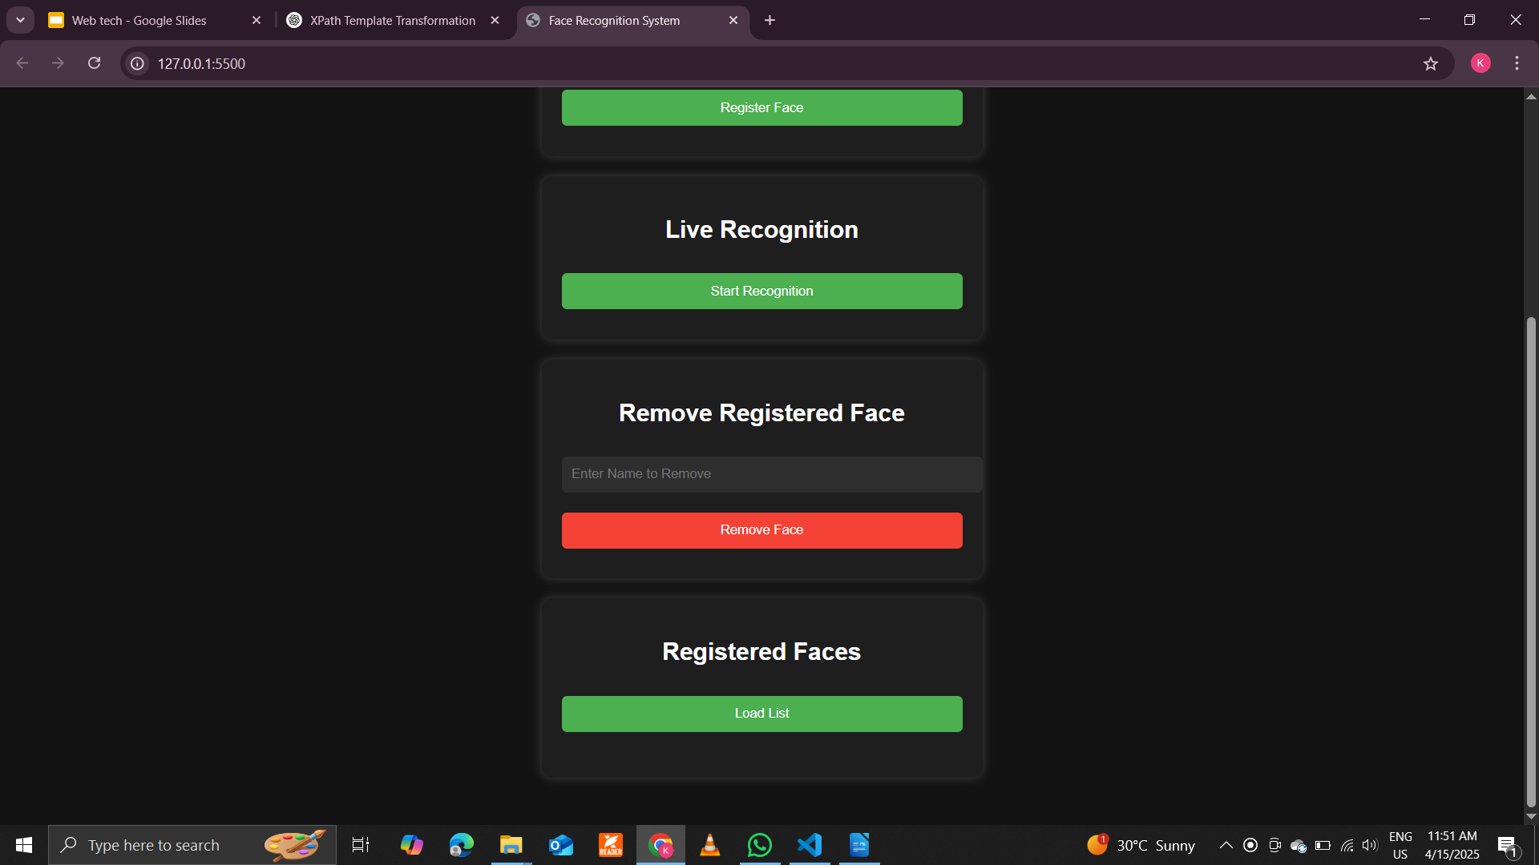

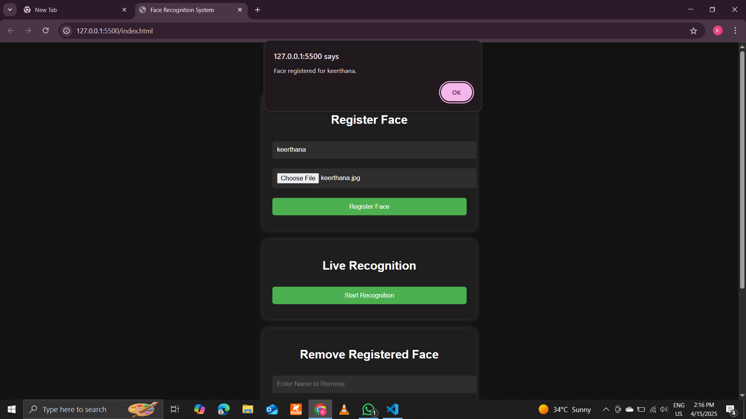

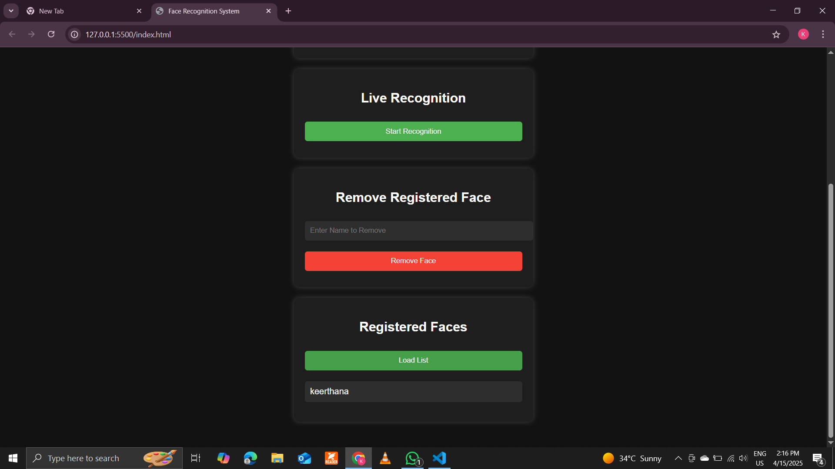

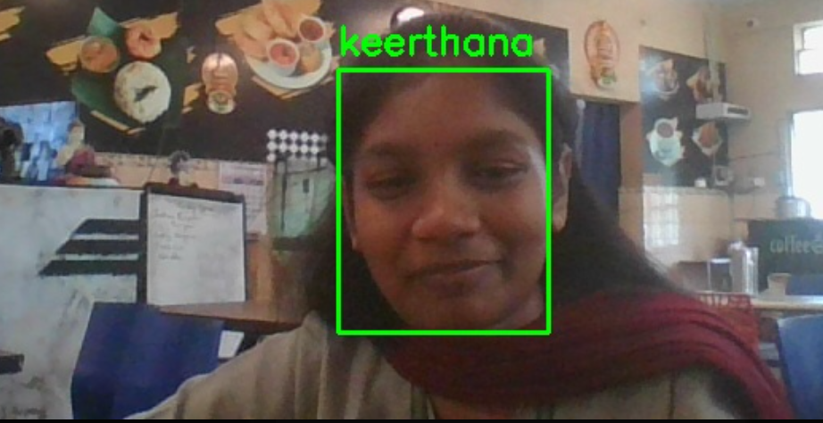

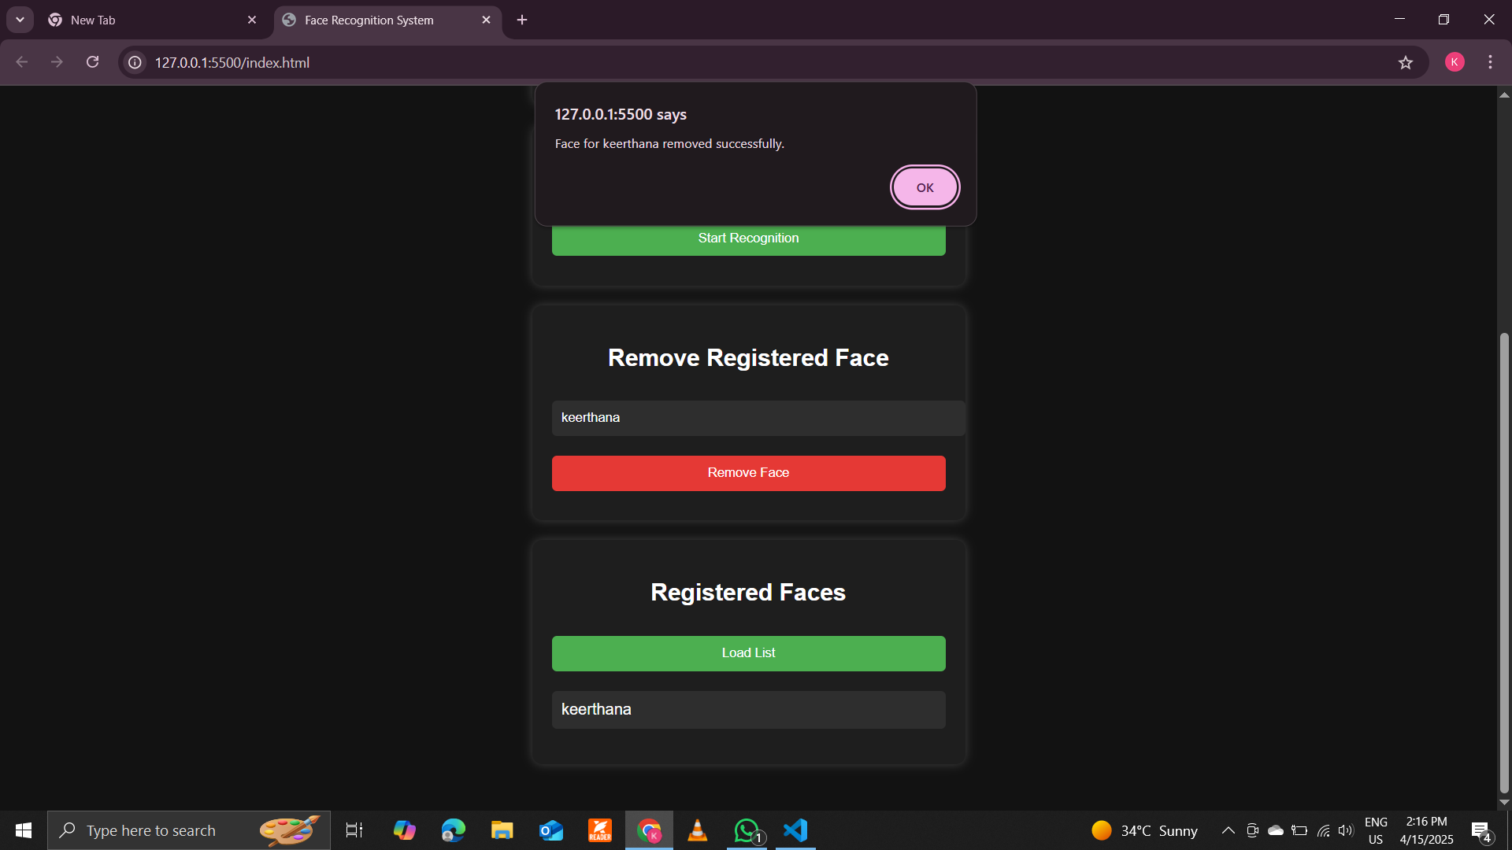

9. Conclusion
This report presented a Face Recognition-Based Vehicle Access Control System designed to prevent unauthorized vehicle usage among tribal school students. By combining AI-powered face recognition with a user-friendly interface, the system ensures only registered individuals can operate vehicles, significantly reducing accidents.
The solution is cost-effective, privacy-focused, and easily deployable, making it ideal for rural and tribal communities. Future work will focus on improving accuracy in challenging lighting conditions and expanding functionality.

